How to change your password
- Go to http://teps-erasmusplus.eu/wp-admin/
- Log in (you have your login details and password in your email inbox). You can change your password if you want. Choose generate password and click on update profile and the password has been changed.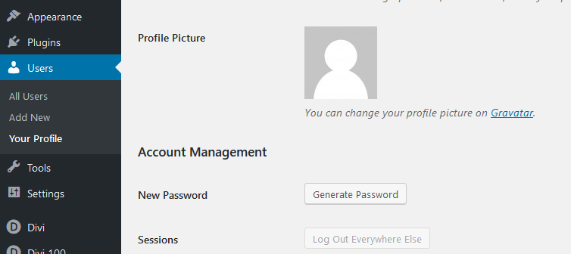

Questions? Problems?
If you have problem email eva.hola@centrum.cz

